VR Natural Survivor

An immersive VR game that teaches essential survival skills for natural disasters through realistic, interactive scenarios.

Team members: Cosma Emil, Cojocaru Adelin Iulian, Hutan Stefan, Bolota Teofil

Description

1. This VR app aims to educate users on natural disaster survival techniques in an engaging and immersive way. Natural disasters like earthquakes require quick thinking and preparedness, and this app provides a safe, interactive platform to practice essential survival skills.
2. The app achieves its purpose by simulating realistic disaster scenarios in VR, enabling users to experience and react to critical situations without real-life risks. Through guided scenarios and interactive challenges, users gain practical knowledge and confidence in handling emergencies.
3. Unlike other educational tools, this app combines VR immersion with a survival-first approach, offering both entertainment and actionable survival insights that are hard to achieve in traditional formats.

Similar products & Relevant Links(>=3)

**Name:** Cities Skylines DLC: Natural Disasters

**Url:** https://store.steampowered.com/app/515191/Cities_Skylines__Natural_Disasters/

**Relevant Features**

- graphical representation of a natural disaster

- map layout

- different angles on disasters

**Name** : Roblox Natural Disaster Survival

**Url** : https://www.roblox.com/games/189707/Natural-Disaster-Survival

**Relevant Features**

- survive different kinds of natural disasters

- different maps

- disaster behavior

**Name** : Earthquake Simulator VR

**Url** : https://store.steampowered.com/app/607590/Earthquake_Simulator_VR/

**Relevant Features**

- simulate building collapse

- experience of being in a disaster

- education aspects

-------------------------------------------------------------------------------------

Main Features

**PRINCIPAL MAIN VERY IMPORTANT FEATURE:**

**Gain experience in a safe environment**

**Other features:**

**- scoring and feedback based on player actions in different situations**

**- interactive tutorials with step-by-step**

**- difficulty settings**

User Journey Diagram - Step by step flow through app

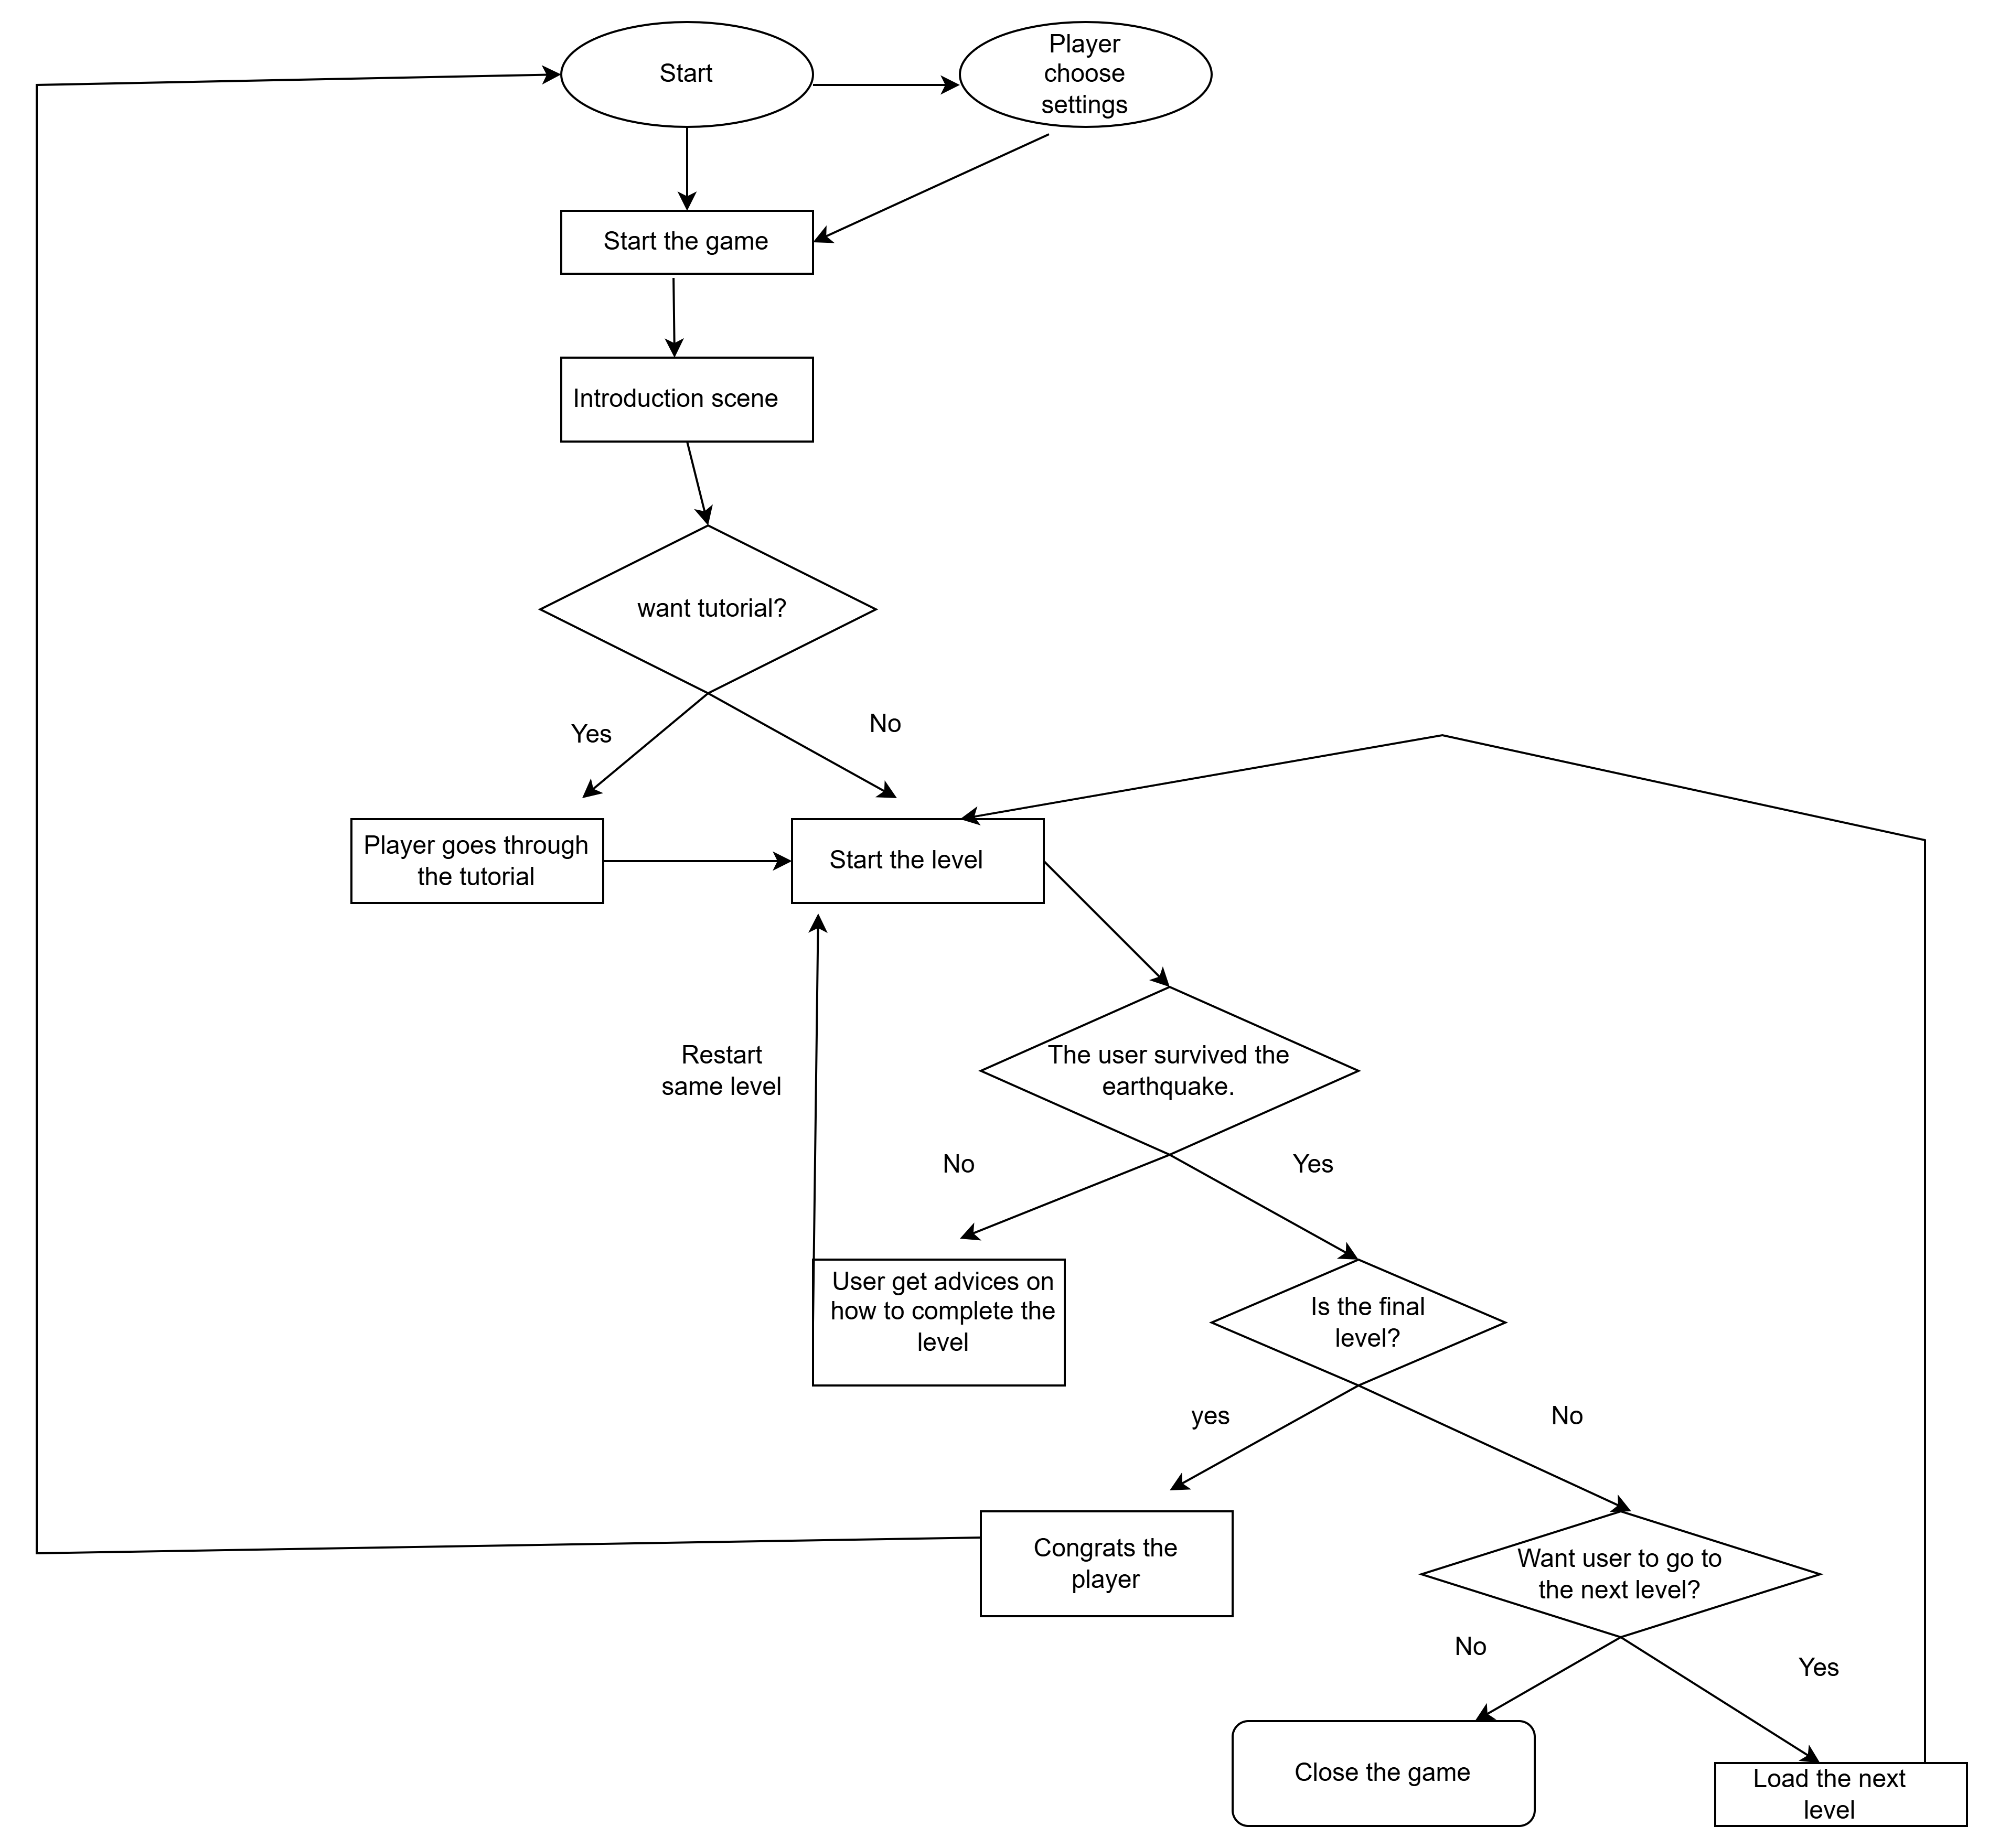

Moodboard (10+ images)

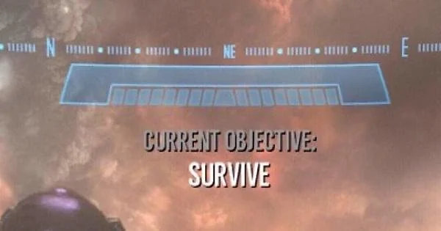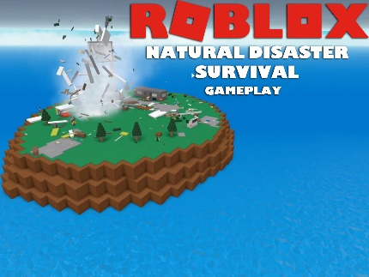

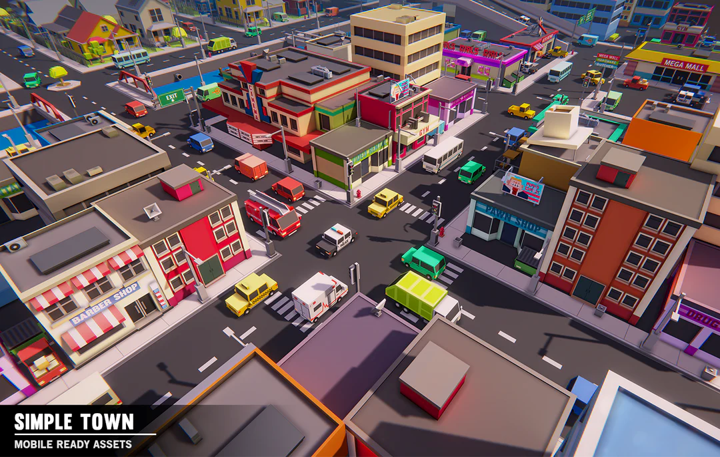

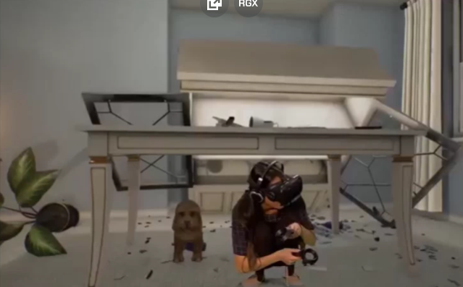

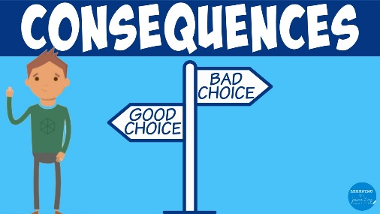

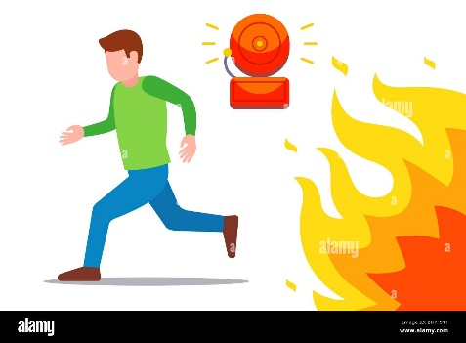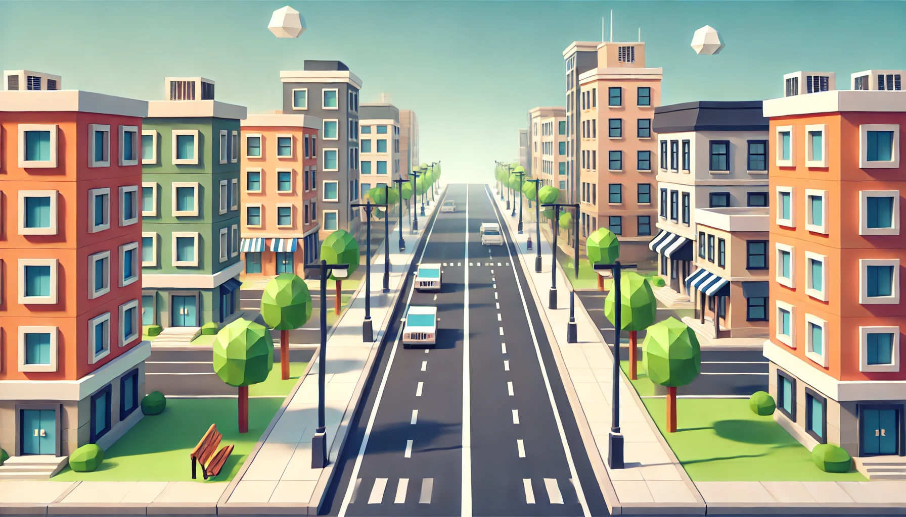



Technologies, Libraries, Assets - Links

1. – Game Engine: Unity
2. – Animation / Modeling: Blender
3. - ARCore: https://github.com/google-ar/arcore-android-sdk
4. - AudaCity: https://www.audacityteam.org/
5. - Unity ShaderGraph: https://unity.com/shader-graph
6. - Unity Particle System Legacy: https://www.youtube.com/watch?v=bQ4INdXtpSM&ab_channel=AlanThorn